Name ____________________________________ Fecha ___________________________________________
La música y el baile
Read the descriptions of each music/dance style on p 35, and then answer the questions at the bottom of the page.
1. _______________________________________ 5. __________________________________________
2. _______________________________________ 6. __________________________________________
3. _______________________________________ 7. __________________________________________
4. _______________________________________
Flamenco:

Tango:

Merengue:

Salsa:

Cumbia:

La geografía
Read the descriptions of each Central or South American landmark then answer the following question in 3-4 sentences.
Which Landmark would you most like to visit? Why?
__________________________________________________________________________________________________
__________________________________________________________________________________________________
__________________________________________________________________________________________________
__________________________________________________________________________________________________
__________________________________________________________________________________________________
__________________________________________________________________________________________________

Otras Lenguas (Other Languages)
Read the descriptions of each language. In the space provided, tell me one interesting fact about each language, then try to guess the meaning of each cognate.
Gallego: ___________________________________________________________________________________________
1. _________________________________ 2. _______________________________________
Catalan: ___________________________________________________________________________________________
1. _________________________________ 2. _______________________________________
Nahuatl: ___________________________________________________________________________________________
1. _________________________________ 2. _______________________________________
Quechua: __________________________________________________________________________________________
1. _________________________________
Fotografía
Navegate to http://www.tomrobinsonphotography.com/ Make sure that you are in the Central America section (menu on the left side). Look at the pictures, then write down 5 similarities and 5 differences between what you see and your everyday life.
Semejanzas (Similarities)
1. ________________________________________________________________________________________________
2. ________________________________________________________________________________________________
3. ________________________________________________________________________________________________
4. ________________________________________________________________________________________________
5. ________________________________________________________________________________________________
Diferencias (Differences)
1. ________________________________________________________________________________________________
2. ________________________________________________________________________________________________
3. ________________________________________________________________________________________________
4. ________________________________________________________________________________________________
5. ________________________________________________________________________________________________

Los Famosos
Research a famous Hispanic person. This could be someone you already know about, or you can find someone new. Then fill out the following information for that person (En español, en frases completas….Duh)
1. Nombre_________________________________________________________________________________________
2. ¿De dónde es? ___________________________________________________________________________________
3. ¿Por qué es famoso? ______________________________________________________________________________
4. ¿Cuándo es su cumpleaños?_________________________________________________________________________

Ropa típica
Look through the pictures starting on p 58 in the book “Para siempre tradiciones ticas” that shows traditional dress for all of the regions in Costa Rica. Pick two that you like and compare them. Why do you think there are so many different styles?
________________________________________________________________________________________________________________________________________________________________________________________________________________________________________________________________________________________________________________________________________________________________________________________________________

Comida Típica
Read the description of each “plato típico” (typical dish) on your table. Take note of the ingredients and the country of origin. Look at the pictures. Do they look appetizing to you? Talk with your group and then answer the following questions on your own.
¿Qué platos te gustan? _______________________________________________
¿Qué plato no te gusta? _______________________________________________
Have you tried any of the dishes? _______________________________________________
Do you want to try any? _______________________________________________
¿Qué es un plato típico de los Estados Unidos? _______________________________________________

Las banderas
Find the country page for each flag depicted, and then color the flags with the appropriate colors. Underneath each flag write the capital of that country.
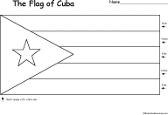  __________________________________ | 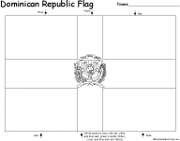  ______________________________________________
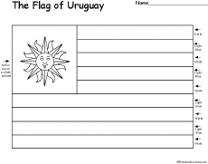  _________________________________________ | 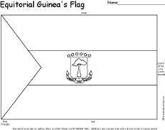  ____________________________________
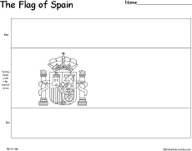
__________________________________________
http://www.enchantedlearning.com/geography/flags/officiallanguage/spanish.shtml

Pyramids of the Sun and Moon at Teotihuacán, Mexico
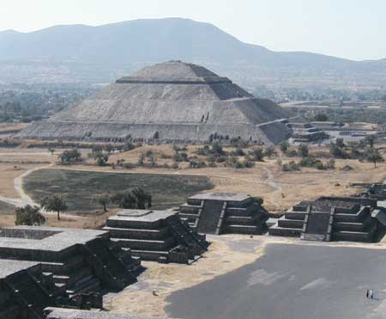
Towering and mysterious, the Pyramids of the Sun and Moon rise above silent Teotihuacán, an empty city that once bustled with as many as 200,000 people and stood at the center of Mexico's pre-Hispanic empire.
Erected by a virtually unknown culture in the first century B.C., the city sprawled over an area larger than imperial Rome. But by A.D. 750 it had been abruptly abandoned, perhaps because of disaster or drought.
Five hundred years later the Aztecs came upon Teotihuacán -- with its pyramids, temples, apartments, and ball courts -- and adopted it as a center of pilgrimage.
At roughly 210 feet high, the Pyramid of the Sun ranks as one of the largest pyramids in the world. (It is about half as tall as the Great Pyramid of Giza in Egypt.) The builders raised the Pyramid of the Sun around A.D. 100, somehow transporting and erecting three million tons of stone, brick, and rubble without benefit of the wheel, beasts of burden, or metal tools.
In 1971, archaeologists found a previously unknown entryway some 320 feet long that leads to a cave directly beneath the apex of the pyramid. At one time the cave held a natural spring, and there are still piles of charcoal in the chamber -- perhaps indicating ceremonies involving water and fire. No one knows, although scientists enjoy speculating.
After climbing 248 steps to the top of the pyramid, you can survey the temple-lined Avenue of the Dead, a roadway about two-and-a-half miles long that ends with the Pyramid of the Moon rising to the north. Finished before A.D. 300, it appears to be as tall as the Pyramid of the Sun. However, it is only 150 feet tall, but built on higher ground. Twelve platforms once stood on the adjacent plaza, where religious dancing may have been performed. Again, no one knows. The mystery endures.
Jerry Camarillo Dunn Jr., http://tlc.howstuffworks.com/family/pyramids-of-the-sun-and-moon-at-teotihuacan-landmark.htm
Easter Island Statues, Chile
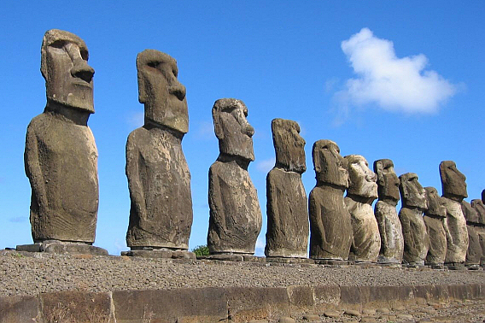
The gargantuan stone figures gaze across Easter Island through eyes hooded in shadow, eyes that veil an ancient, mysterious past. The place where they stand floats alone in the South Pacific, about 2,000 miles from the coast of Chile. It is the most remote inhabited island on Earth.
The statues, called moai, average 23 feet tall, with the largest one measuring an incredible 69 feet. Many of the figures originally stood on stone platforms, and some wear topknots of reddish stone, which some archaeologists believe represents a male hairstyle once common on the island. The huge topknots weigh as much as two elephants, yet they were somehow set in place atop the figures.
Scholars believe that Marquesas islanders migrated to Rapa Nui (the island's original Polynesian name) before A.D. 400. According to local legend, however, there were two groups of early settlers -- known as the Long Ears and the Short Ears -- that came from different directions.
It isn't clear which group carved the moai, but conflict between them led to the extermination of the Long Ears and damaged many monuments. Later, rival clans that owned the statues toppled the moai to offend and anger each other. Today fallen statues lie scattered around the island. In the 20th century some were restored to their upright positions.
Of the island's 887 moai, nearly half are partially carved figures that still remain in the island's quarry, lying horizontally, face up. Shaping even a medium-size statue probably took two teams of men at least a year. Each figure was then detached, lowered down a cliff, and somehow moved a great distance to its site -- perhaps hauled on a tree-trunk sledge, transported on wooden rollers, or rolled on round stones. Finally, the immense figure had to be raised upright on an elevated platform.
Originally, the statues of Easter Island did not have the blank, empty eyes seen today, but orbs of inlaid coral and rock. Upon what lost world did they gaze?
Jerry Camarillo Dunn Jr, http://tlc.howstuffworks.com/family/easter-island-statues-landmark.htm
http://www.easterislandquest.com/img-welcome-easter-island.jpg
Machu Picchu, Peru
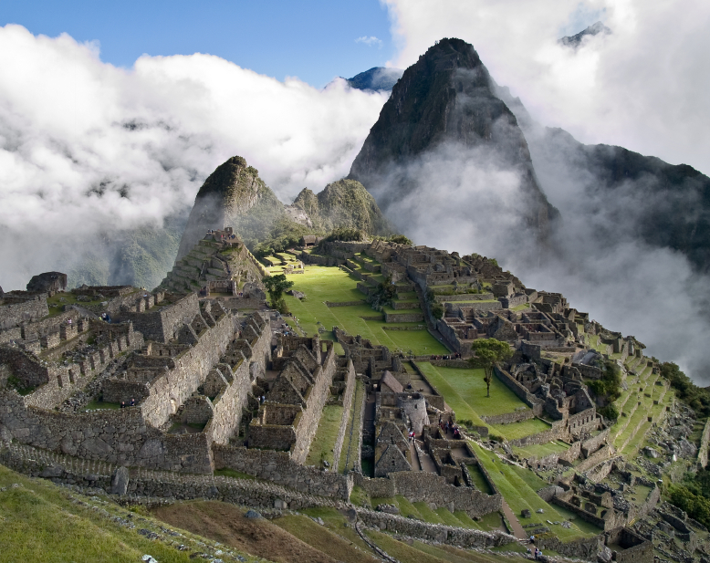
A lost city floating in a kingdom of clouds. A stone Shangri-la set high in the Andes mountains of Peru. A mysterious settlement that the Incas built, occupied, and deserted, all in less than a century. This is Machu Picchu.
For hundreds of years the city was hidden in the jungle. Then, in 1911, a Yale professor named Hiram Bingham led a university expedition to the Peruvian Andes. On a valley floor along the Urubamba River, he met a farmer who guided him up to the ruins of the hidden city -- the only Incan site that hadn't been looted or destroyed during the previous four centuries.
Looking at the city's finely cut stone buildings, Bingham thought he had discovered Vilcabamba, the legendary last refuge of the Incas. Eventually, however, archaeological evidence piled up to the contrary. Machu Picchu instead seems to have been the hub of a sizable Incan province. According to recent evidence, the city may have been built by Pachacuti, the founding patriarch of the Incan empire, and populated by his royal house. If this supposition is correct, Machu Picchu would have been constructed sometime after 1438, when Pachacuti decisively repelled enemy invaders and the Incas began expanding their empire.
Machu Picchu spans a mountain saddle between green jungle peaks. The settlement has only 200 residences, suggesting a population of about 1,000 people. Because the nearby agricultural lands could support a much larger population than this, some archaeologists theorize that the settlement's role was to grow coca leaves to send to the priests and nobility of the nearby Incan capital of Cuzco.
Jerry Camarillo Dunn Jr., http://tlc.howstuffworks.com/family/machu-picchu-landmark.htm
http://www.peru-machu-picchu.com/

Catalan (català)
Catalan is a Romance language spoken by about 12 million people. It is the official language of Andorra and an official language, along with Spanish, in Catalonia (Catalunya), Valencia (Comunitat Valenciana), the Balearic Islands and the Sardinian city of Alghero (l'Alguer). It is also spoken in parts of Aragon and Murcia, Rousillon (Rosselló) in southern France, though has no official status.
The language of Valencia is known as Valencian, which some Valencians argue is a separate language. Most linguists view it as a variety of Catalan.
Catalan appeared as a distinct language during the 10th and 11th centuries. During the 12th century, Catalan began to appear in writing in scientific, philosophical, financial, religious, legal, literary and historical documents. At that time, Latin and Provençal were the preferred languages for literary and philosophical texts.
1.Com estàs? 2. Bon dia
http://www.omniglot.com/writing/catalan.htm

Galician (Gallego)
Galician is a Romance language spoken by about 3 million people in Galicia, in the north-west corner of Spain. Galician is more or less mutually intelligible with Portuguese but uses Spanish spelling conventions. In fact, whether Galician and Portuguese are separate languages or dialects of the same language, is a question that has been hotly debated for decades, and is loaded with political and cultural implications.
Galician emerged as a standardised literary language during the 19th century when there was a revival (rexurdimento) in the language and culture of Galicia.
An attempt in the 1930s to give autonomy to Galicia and official status to Galician was never promulgated due to the Civil War (1936-1939), and speaking of Galician in public was banned during Franco's dictatorship (1939-1975).
Galician gained official status in 1978 and is recognised as one of Spain's five official languages (lenguas españolas), along with Spanish (Castilian), Catalan, Basque and Aranese. Primary and secondary schools in Galicia teach bilingually in Galician and Spanish, and Galician is the main medium of instruction in universities in Galicia.
Some one thousand or so books are published in Galician each year and there is a Galician TV channel, established in 1985, a Galician radio station (set up in 1996), and a daily Galician language newspaper, O Correo Galego.
In cities in Galicia more Spanish than Galician tends to be spoken, however Galician is widely-spoken in rural areas.
1. Ola 2. Adeus
http://www.omniglot.com/writing/galician.htm

Nahuatl (nāhuatl/nawatlahtolli)
Nahuatl is an Uto-Aztecan language spoken by about 1.5 million people in Mexico. The majority of speakers live in central Mexico, particularly in Puebla, Veracruz, Hildago, San Luis Potosi, Guerrero, Mexico (state), El Distrito Federal, Tlaxcala, Morelos and Oaxaca, and also in El Salvador. There are smaller numbers of Nahuatl speakers throughout the rest of Mexico, and in parts of the USA.
There are numerous dialects of Nahuatl, some of which are mutually unintelligible. Most Nahuatl speakers also speak Spanish, with the exception of some of most elderly.
Classical Nahuatl was the language of the Aztec empire and was used as a lingua franca in much of Mesoamerica from the 7th century AD until the Spanish conquest in the 16th century. The modern dialects of Nahuatl spoken in the Valley of Mexico are closest to Classical Nahuatl.
Nahuatl was originally written with a pictographic script which was not a full writing system but instead served as a mnemonic to remind readers of texts they had learnt orally. The script appeared in inscriptions carved in stone and in picture books, many of which the Spanish destroyed.
The Spanish introduced the Latin alphabet to write Nahuatl, and a large amount of prose and poetry was subsequently written. Every since there has been considerable debate about how to spell Nahuatl.
1. tomatl 2. tamalli

http://www.omniglot.com/writing/nahuatl.htm

Quechua (Qhichwa)
Quechua is an Amerind language with about 8 million people in Bolivia, Peru, Ecuador, Colombia and Argentina. Quechua was the language of the Inca empire which was destroyed by the Spanish in the 16th century.
The Inca used a system of knotted strings known as quipu to send messages around their empire. The number and shape of the knots and the colours of the strings helped to remind messengers of the contents of the messages. Recent research suggests that the quipu might have been used not just as mnemonic devices but also to record the Quechua language phonetically.
Quechua first appeared in print in 1560 in the form of a dictionary by Domingo de Santo Tomás. Other early texts include collections of hymns by Cristóbal de Molina and a Quechua cathechism by Juardo Palomino.
1. puma
http://www.omniglot.com/writing/quechua.htm

EL GALLO PINTO (“painted rooster” –Costa Rica)
Ingredients:
1 cup of cooked rice
1 cup of cooked beans
1 chopped onion (small)
1 small chopped red pepper
2 cloves of garlic chopped
1 tbs oil
¼ cup chopped cilantro
4 Tbs. Salsa Lizano
Pinch of black pepper
1 tbs seasoning

Preparation:
1. Fry onion, red pepper, garlic, cilantro in the vegetable oil, about 3 minutes.
2. Pour in the beans and add the sauce, black pepper and seasoning. Let it cook for a few minutes, but don’t let it dry out.
3. Pour in the cooked rice and mix it with the beans

Enjoy with:
Sour Cream
Platanos maduros
Eggs (fried or scrambled )

Cultural notes:
When the beans and rice are combined, the rice gets colored by the beans, and the mix results in a multi-colored, or speckled appearance. It is also traditionally believed to have developed to conceal the lack of meat in the dish, either because it is unavailable or too expensive. So the host serves a dish hoping that those eating it will be fooled into believing it contains chicken, the lack of which being disguised by the texture and speckled appearance of the bean and rice mixture. Those eating are rarely fooled, however, so the pejorative name "gallo pinto" suggesting the dish has been merely "painted rooster" arose.

http://blog.therealcostarica.com/2005/12/02/yum-gallo-pinto/

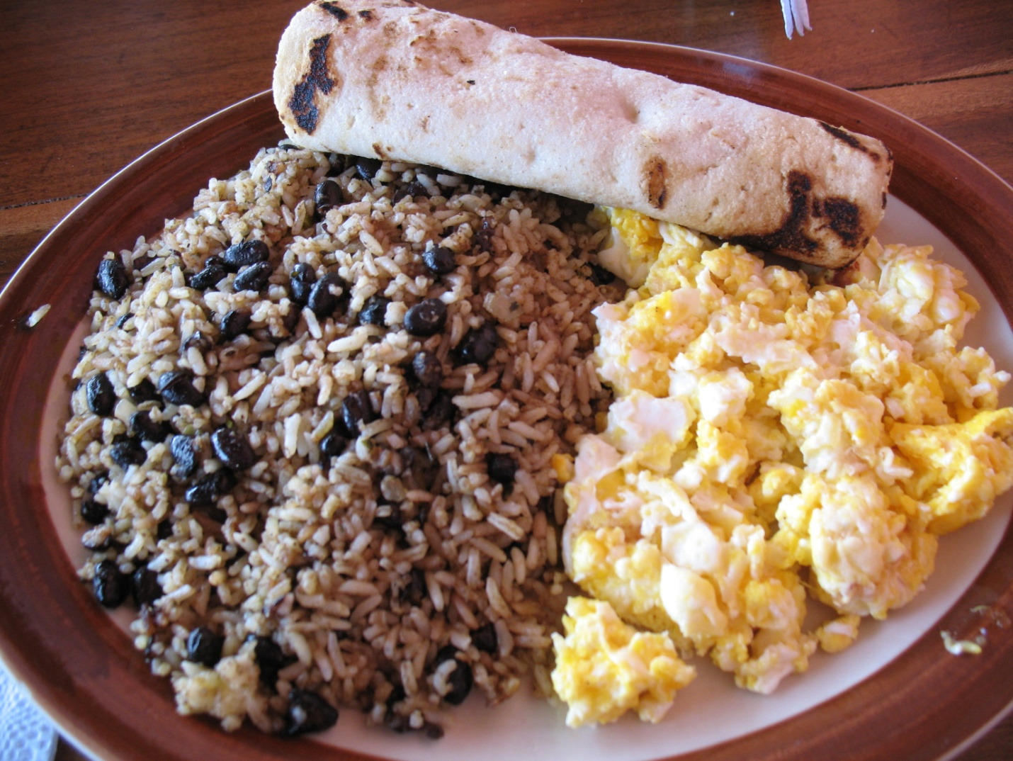

http://v14.lscache4.c.bigcache.googleapis.com/static.panoramio.com/photos/original/2307793.jpg

PAELLA (España)

Ingredients:

½ lbs cuttlefish
½ lbs calamari (squid)
8 big jumbo shrimp
4 spiny lobsters, crayfish or smaller lobsters
12 fresh mussels
2-3 fresh oysters
1 tablespoon of sweet paprika
Olive oil
8 tablespoons of tomatoes, cut into pieces
Saffron
2 ½ cups of rice
2-3 garlic cloves
1 – 1 ½ liters of fish soup

Preparation:
The fish soup is ideally to be prepared at home, using the head and tail of a fish, some onion, laurel, salt and one tomato. Calamari and cuttlefish are cut into pieces.
Give the oil into a pan and warm it. Add the shrimp and crayfish and fry them for 2 – 3 minutes. Set them aside afterwards. In the very same oil fry the cuttlefish and the calamari (squid). When they turn golden add the tomatoes and the minced garlic. Let them fry until they become darker. After that add the paprika, stir everything and add the rice.
Stir very well for one minute, pour the warm fish soup over it and add another clove of minced garlic.
Let the rice at medium to high heat. After some 10 minutes add the shrimp and crayfish, the mussels and the oysters. Let them cook for another 5 minutes.
http://www.paellarecipe.org/55/paella-dish-recipe/

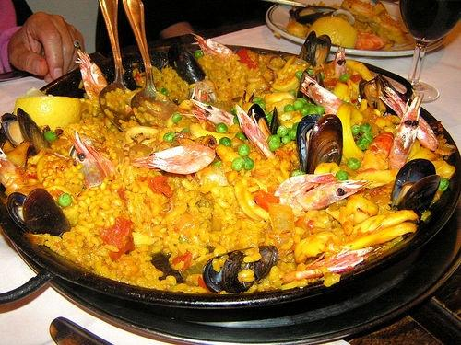

http://1.bp.blogspot.com/-1Lcf5MieYPc/Tiki-DqGKFI/AAAAAAAABHA/sozvGJVe7IY/s1600/paella.jpg

ROPA VIEJA (“old clothes” Cuba y el resto del Caribe)

Ingredients:

1 tablespoon vegetable oil

2 pounds beef flank steak

1 cup beef broth

1 (8 ounce) can tomato sauce

1 small onion, sliced

1 green bell pepper, seeded and sliced into strips

2 cloves garlic, chopped

1 (6 ounce) can tomato paste

1 teaspoon ground cumin

1 teaspoon chopped fresh cilantro

1 tablespoon olive oil

1 tablespoon white vinegar

Preparation:

Heat vegetable oil in a large skillet over medium-high heat. Brown the flank steak on each side, about 4 minutes per side.

Transfer beef to a slow cooker. Pour in the beef broth and tomato sauce, then add the onion, bell pepper, garlic, tomato paste, cumin, cilantro, olive oil and vinegar. Stir until well blended. Cover, and cook on High for 4 hours, or on Low for up to 10 hours. When ready to serve, shred meat and serve with tortillas or rice.
http://allrecipes.com/Recipe/cuban-ropa-vieja/detail.aspx

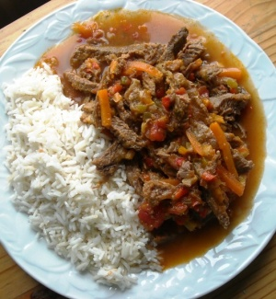

http://www.cookipedia.co.uk/wiki/images/thumb/3/31/Ropa_Vieja_a_la_Cubana_recipe.jpg/300px-Ropa_Vieja_a_la_Cubana_recipe.jpg

HORCHATA (México)

Ingredients:
1 cup rice
1/2 of a cinnamon stick
1 teaspoon lime zest
5 cups drinking water
1/2 cup sugar

Preparation:
Grind the rice in your blender until it is ground smooth. Toss with cinnamon stick and lime zest. Let rest overnight.
After resting, place rice mixture into blender and blend until smooth. Add in 2 cups of water to mixture and soak for 2 hours.
Strain the liquid through a fine sieve or cheesecloth a few times to remove any grittiness.
Add in the rest of the water (3 cups) and stir in sugar until dissolved.
Garnish with a sprig of mint.

Cultural note:
Horchata is a traditional beverage found throughout Latin America and Spanish. Traditionally the Mexican version of horchata is made with rice. It is flavored with lime and cinnamon and sweetened with sugar. Originally horchata was made with the chufa nut and sometimes melon or squash seeds.
The rice, nuts or seeds are ground and mixed with water to make a milky looking drink.
This drink can be found in most Mexican restaurants and is often sold by street vendors in Mexico. Since it does not contain milk, it will not spoil as easily as a dairy containing beverage. The origins of this drink stem from Egypt where they originally used the chufa nut to make horchata. During ancient times, the drink made its way to Spain. When the Spaniards brought the drink to Mexico, the natives used rice to make the drink.

http://mexicanfood.about.com/od/mexicanfoodglossary/g/defhorchata.htm

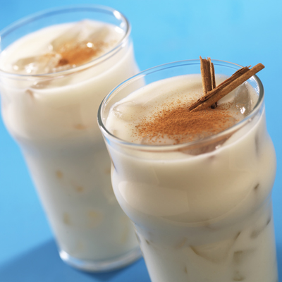
http://www.meals.com/ImagesRecipes/144029lrg.jpg

